|  |
| --- |
|  |

|  |
| --- |
|  |

|  |
| --- |
|  |

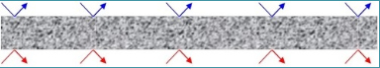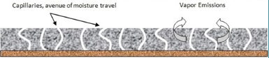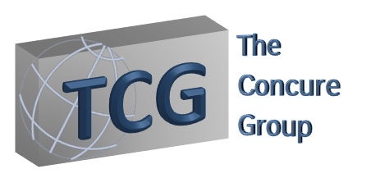

The primary use of Concure Admix is for waterproofing new on-grade, below-grade concrete slabs and elevated decks. This type of admixture takes the guesswork out of where to use a vapor retardant. Using Concure Admix assures architects and flooring manufactures that flooring materials will not fail due to moisture migration or capillary action through or out of the slab. Concure Admix is added to the concrete mix at the batch plant or can be added on site. Concure Admix is environmentally safe and contains no volatile organic compounds.

**After: Non - Porous Substrate**

**Before: Porous Substrate**

* Compatible with all floor coverings, coatings and approved adhesives for non-porous substrates
* Densifies concrete and contributes to increased concrete strength up to 125%
* Stops ASR(Alkali-Silica-Reactivity)
* Works as a shrink reducing admix(SRA)
* Reduces most slab curling due to uneven slab curing
* Minimizes spalling and surface cracks
* Eliminates efflorescence
* Eliminates surface dusting

## Advantages

* Trusted since 1991
* Does NOT require use of an under slab vapor retarder/barrier
* Integral in the slab and NEVER requires topical sealing
* Fraction of cost to use versus topical suppressants
* Flooring can usually be installed 30 days after pouring the concrete
* Eliminates moisture problems

Phone: 267-356-7994

info@concuregroup.com

www.theconcuregroup.com

18 Campus Blvd,

Suite 100

Newtown Square, PA 19073

### THE MIX FOR PERFECT CONCRETE

Concure Admix